Chapter 2:
Driver’s Seat

Objectives

After completing this section, you will be able to:

- View/Change Dashboards
- Add / Update / Delete Asset Reservations
- View Asset Reservations
- Send a Non-Equipment Related Maintenance Request (NERMR)
- Send an Asset Related Maintenance Request
- Use / Edit the Time Clock
- View / Send / Delete Messages

Contents
Driver’s Seat 47
Dashboard 47
Default Dashboard: 47
Inventory Dashboard 48
Real Time Status Dashboard 49
Dashboard Controls 51
Asset Reservations 51
Operations 54
Collecting Data 56
Non-Equipment Related Maintenance Request (NERMR) 61
Messages 64
Reading Messages 64
How to Send a New Message 64
Table of Figures
Figure 1 Default Dashboard Screen 48
Figure 2 Inventory Dashboard Screen 49
Figure 3 Real Time Dashboard Screen 50
Figure 4 Dashboard Settings Screen 50
Figure 5 Logged In User's Asset Reservations List on Default Dashboard 51
Figure 6 Asset Reservation Calendar 52
Figure 7 Asset Reservation Details Screen 52
Figure 8 Asset Reservations - Recurrence Details Screen 53
Figure 9 Asset List on Operations Control 54
Figure 10 Asset LookUp Screen 55
Figure 11 Operations Details Screen 55
Figure 12 Asset Status Update Screen 56
Figure 13 Asset Data Collection Screen 57
Figure 14 Example of Text, Date, Number and Checkbox Variables 57
Figure 15 Example of Document Variable 58
Figure 16 Example of Formula Variable 58
Figure 17 Example of Totalizer Variable 59
Figure 18 SPC Data Collection Screen and Xbar Chart 59
Figure 19 Data Viewed in Grid 60
Figure 20 Point Detail Screen 60
Figure 22 Example of Run Rules Setup (See Chapter 10 Settings for More Detail) 61
Figure 23 Non-Equipment Related Maintenance Request Screen 62
Figure 24 Repair Request Screen 63
Figure 25 Message Screen 64
Figure 26 New Message Screen 65
Figure 27 Message Recipient Screen 65

Driver’s Seat

The Driver’s Seat contains the Dashboard and Messages submodules as well as the Reports Browser. The Message submodule is where a User can receive and send regular and/or must-read emails to existing Users. The Reports Browser is described within the Reports chapter.
The Dashboard submodule consists of a selection of controls that provide different viewpoints of information from the system. Custom controls can be created and included as selections for the Dashboard. Currently, there are three Dashboards included with TME.

Dashboard

Default Dashboard:
- Asset Reservations allows assets such as production equipment to be scheduled for use, maintenance, repair or overhaul.
- The Operations control allows Users to create different kinds of requests that may or may not be associated with an Asset. It also provides the User with access to a copy of the asset detail screen and a 30 Day Status Summary. The User can also make Service and Repair requests, enter Data Collections and update the Asset's Minor Status within Uptime (Production vs. Standby vs. Engineering).
- The Time Clock is a timestamp tool whereby a User can clock in or out. The Clock In button or Clock Out button displays depending on what transaction was done last.

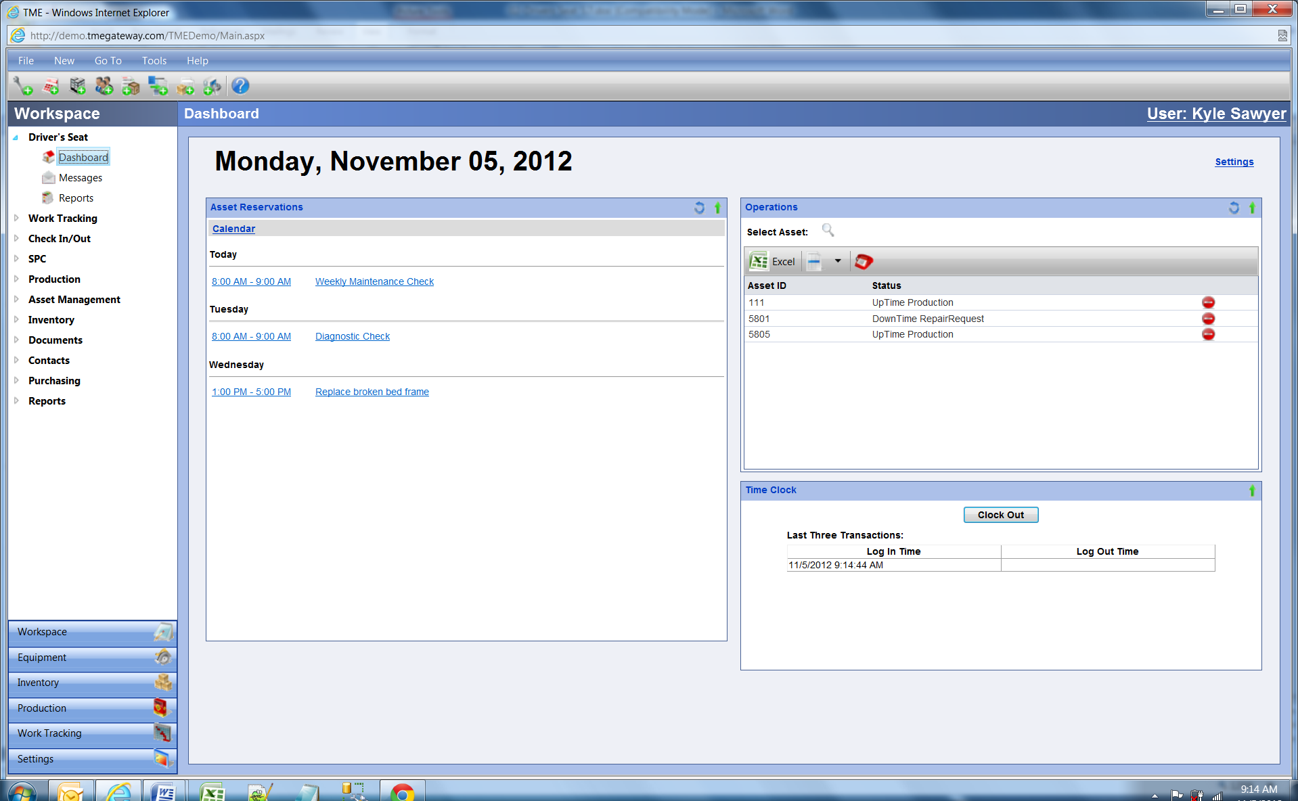
Figure 1 Default Dashboard Screen

Inventory Dashboard
- Inventory shows all items that are on order via Purchase Orders and their total quantity on hand system wide (all locales).
- The Operations control allows Users to create different kinds of requests that may or may not be associated with an Asset. It also provides the User with access to a copy of the asset detail screen and a 30 Day Status Summary. The User can also make Service and Repair requests, enter Data Collections and update the Asset's Minor Status within Uptime (Production vs. Standby vs. Engineering).

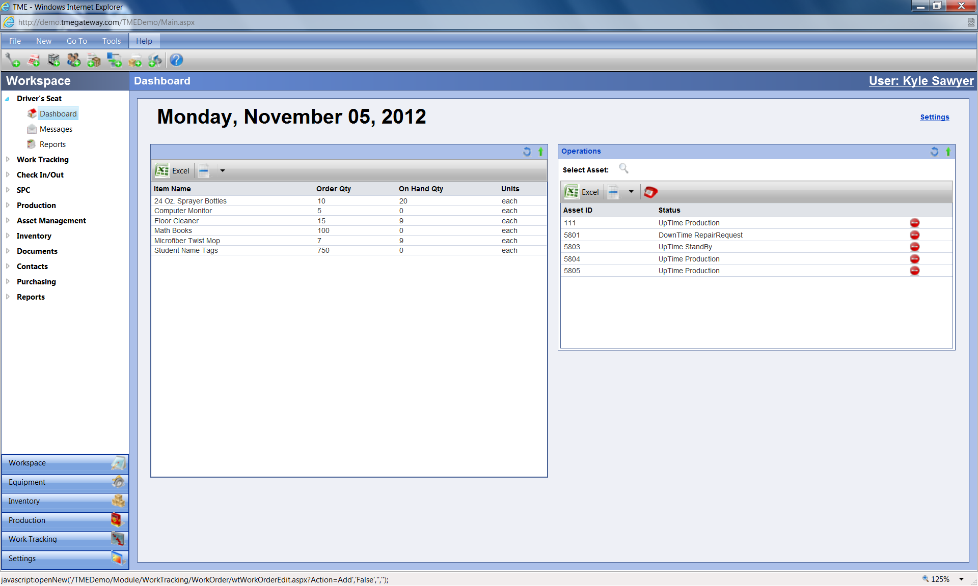
Figure 2 Inventory Dashboard Screen

Real Time Status Dashboard

- Users (provided with the appropriate security setup) are able to view the real time status of all their Assets as well as a list of those Assets that are currently in a Downtime state. By clicking on the square representing an Asset, the User opens the Operations detail screen for that Asset and is then able to have access to a copy of the asset detail screen and a 30 Day Status Summary. The User can also make Service and Repair requests, enter Meter Readings and update the Asset's Minor Status within Uptime (Production vs. Standby vs. Engineering).

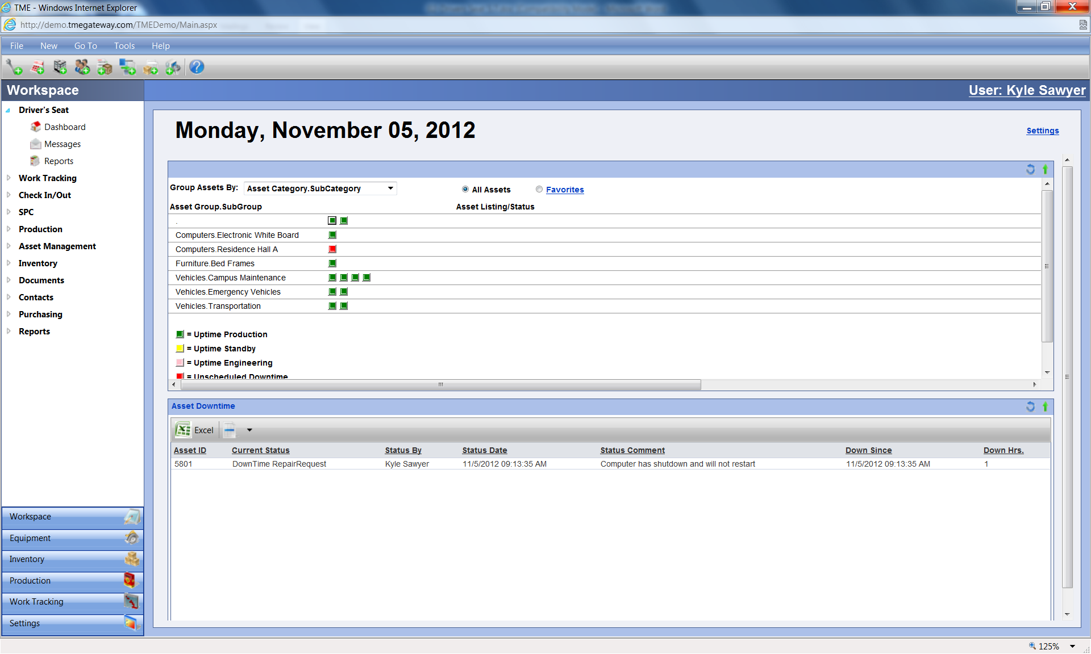
Figure 3 Real Time Dashboard Screen

To switch from one Dashboard to another, click on Settings at the top left corner of the screen, select from the drop down list on the popup screen and click OK.

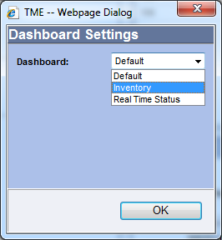
Figure 4 Dashboard Settings Screen

Dashboard Controls

Asset Reservations

The Reservation Calendar is designed to allow Users to work on an Asset or relocate it without interruption from other Users. Like any reservation system, this provides a solution to avoid conflicts between Users.

Pathways to the Reservation Calendar

Asset Reservations can be made via three different methods—through the Dashboard control, Scheduled Work (see the Work Tracking chapter) and Asset Management (see the Asset Management chapter). All three methods store the information in the same place: on the Reservation Calendar. At any time, a User can view a reservation regardless of the method by which it was created by accessing the Reservation Calendar through any of these Modules.

The Asset Reservations control on the Dashboard shows the reservations set up by the user for the current week. Place the cursor over the time slot or reservation description and a pop up window will appear with the Reservation ID, Asset ID, Subject and Status. Clicking on the time slot or reservation description will bring up the Reservation Screen. Clicking on will bring up the Reservation Calendar.

Exercise 1:
 Add a weekly reservation for an Asset starting tomorrow and lasting five months.

- Go to Driver’s Seat > Dashboard.

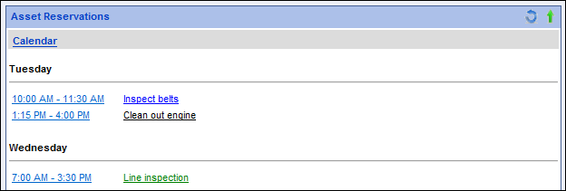
Figure 5 Logged In User's Asset Reservations List on Default Dashboard

2. Click on the link.

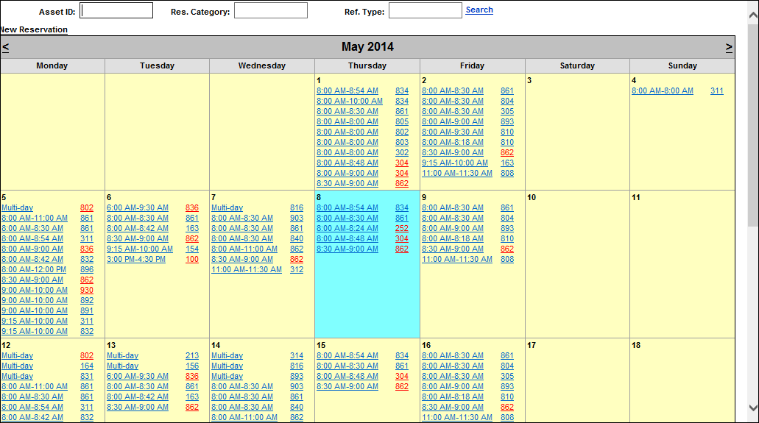
Figure 6 Asset Reservation Calendar

The block for the current date is filled in blue. Placing the cursor over the time or the Asset ID brings up the Subject and Status of the reservation. The Asset ID’s font color is determined by the category of the reservation. To filter the calendar by an Asset ID, type or scan the Asset ID in the Asset ID field and click on .

- 3. Click on the link. The Reservation detail screen appears.

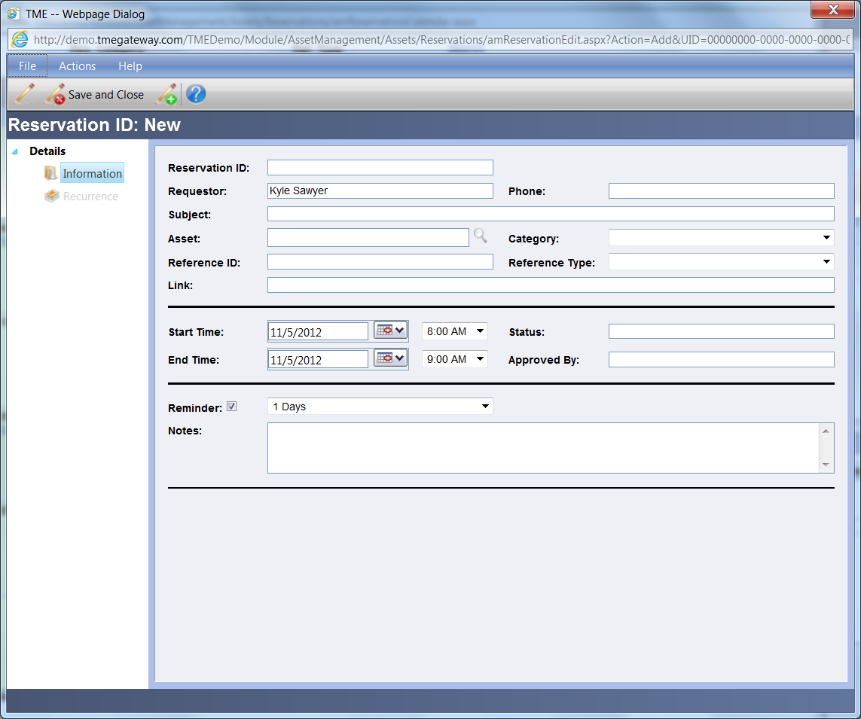
Figure 7 Asset Reservation Details Screen

- 4. Type in the Subject and Reference ID. Select an Asset ID, Category, Reference Type, Start Date and Time, End Date and Time and have a reminder email sent two days prior to reservation. (The email reminder will be sent out automatically by the system.)
- 5. Click on Save. The Additional link for Recurrence will activate. Click on it.

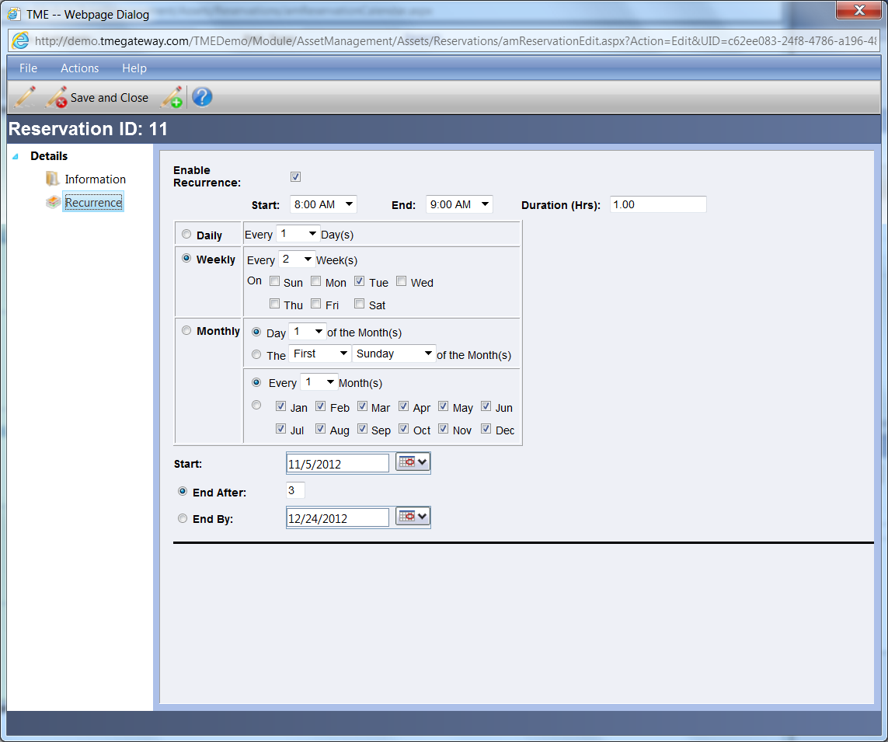
Figure 8 Asset Reservations - Recurrence Details Screen

7. Select Enable Recurrence.
8. Select the schedule and either End After or End By; verify that times and Start
Date are correct (the Reservation tab’s times and dates are now grayed out—
times and dates are now controlled only via the Recurrence tab).
9. Save and close the record.
10. Repeat and add a monthly reservation for the 5th day of the month, a single
reservation for next week and a reservation that lasts for four days.

Exercise 2:
 Update a reservation and delete another.

- 1. Change the four day reservation to last five days.
- 2. Delete the monthly reservation.
- .

Operations

The Operations control on the Dashboard allows Users to create different kinds of requests and collect data associated with an Asset. It also provides the User with access to a copy of the asset detail screen and a 30 Day Status Summary.

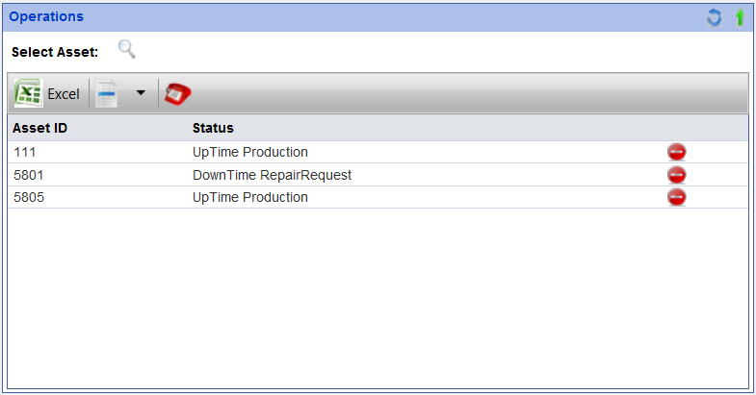
Figure 9 Asset List on Operations Control

Adding an Asset to the Operations Viewer

Exercise 3:
Add an Asset to the Operations Viewer.

- 1. Go to Driver’s Seat > Dashboard
- 2. Click on the Select Asset icon . The Item LookUp screen will appear and contains the list of assets for which permission to access has been provided. The Search, Views, Records per Page and Add New (if permission has been provided) functions are available at the top of the screen.

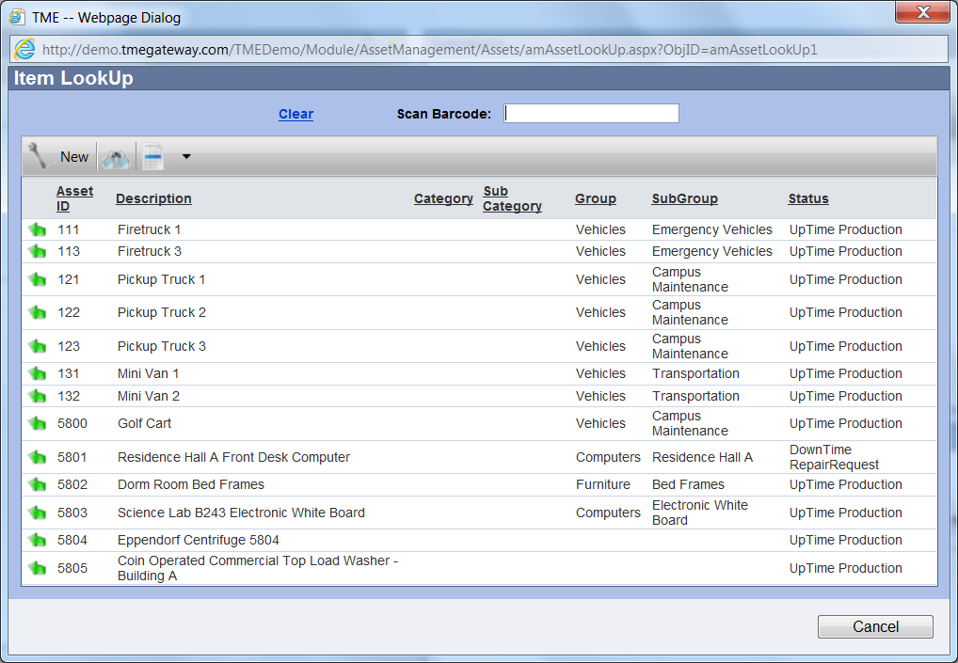
Figure 10 Asset LookUp Screen
- Select the asset by clicking on the Select Item icon to the left of the Asset ID. The screen will disappear and the selected asset is now included in the Operations viewer and the Operations screen for the asset will automatically appear.
The Dashboard has a default setting of allowing up to twenty one Assets may be listed at any given time. The asset viewed last will be removed to make room for newly selected assets. If more than twenty one Assets are needed, contact the TME Administrator to change the setting.

Asset Information on the Operations Screen

To access the Operations screen of an Asset, double click anywhere within the row of the asset or right click within the row and select "View." The Operations screen will appear.
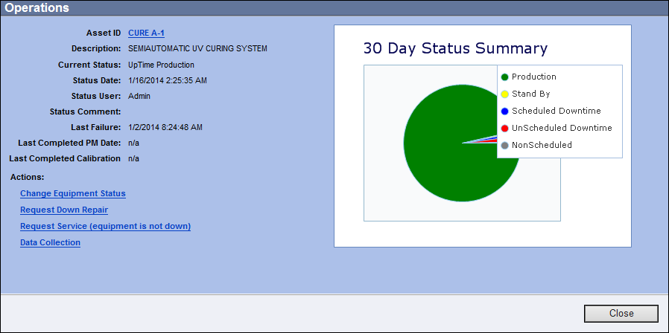
Figure 11 Operations Details Screen
This screen has links for sending support requests as well as basic information on the asset: ID, Description, Current Status, Status Date, Status User, Status Comment, Last Failure, Last Completed PM Date, Last Completed Calibration, 30 Day Status Summary as well as SPC charts if they are available. The 30 Day Status Summary is a pie chart that shows what proportion of the last 30 days the status of the Asset was Down, Up or Nonscheduled.
Even more information can be accessed by clicking on the Asset ID itself. The Asset Detail screen will appear. Click on at the top right corner or the Close button at the bottom of each screen to close.

Changing the Equipment Status (within the Uptime State)

If the Asset is in the Uptime State, the minor status of the Asset may be changed by clicking on . The Status popup screen will appear. Change the minor Status to/from Standby, Production, or Engineering accordingly. Comments may be typed into the Comments field.
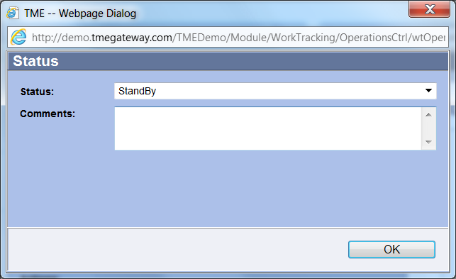
Figure 12 Asset Status Update Screen

Collecting Data
Numerous pieces of data can be collected on an Asset via the Operations screen. The data can be meter readings, documents, inspection results, etc. To collect data, click on . The Asset Data Collection screen will appear.

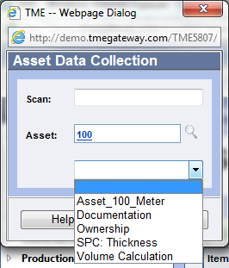
Figure 13 Asset Data Collection Screen

Choose the appropriate Collection from the drop down screen and click on . The Collection screen will open with the fields for which data is to be collected. If a variable onscreen is required, it may have a default entry already applied. If the default entry applies, changes are not needed. If the default entry is incorrect for the record, then change the value accordingly. Click Submit when finished entering data.

Text, Date, Number, List, and Checkbox Variables
To enter a value into a Text variable, click in the field and type the entry. For a variable that requires a Date, click on the Open the Calendar Popup icon and select the date. Some variables require the entry of a Number, click in the field and type in the number. For those variables with a drop-down List, click on the arrow on the right side of the drop-down field and select the appropriate entry. If a variable has a Checkbox, click the checkbox if the value is to be applied to the Asset.
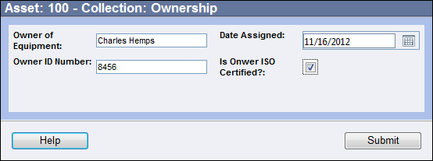
Figure 14 Example of Text, Date, Number and Checkbox Variables

Document Variable
To upload a file or enter in a URL address for a Document variable, click on the Attach Doc icon to the right of the field. The Document Selector screen will appear. If uploading a file, click on the Select button and browse to the file. If no Select button is available, type in the full URL address for the document. Click Save when finished. The Document name will appear in place of "No Document Selected" or the name of the previously uploaded file.
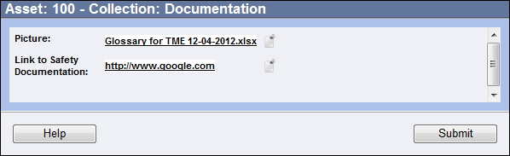
Figure 15 Example of Document Variable

Formula Variable
To view the calculation for a Formula prior to saving the record, make sure all number variables have been populated and click on the Calculate icon to the right of the formula field. If the calculation cannot complete due to the number variables not being filled in (or the numbers and/or calculation are not within preset limits), there will be "--Error--" inserted into the field. Otherwise, the formula will calculate and populate the result.
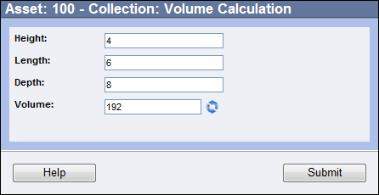
Figure 16 Example of Formula Variable

Totalizer Variable
The Totalizer variable replaces the meter feature from previous versions of TME prior to 5.8. This variable works in exactly the same way as the meters. The data is just collected in a different way. To enter a value, type it in to the totalizer field. If the value does not fall within the preset limits, a popup message will appear upon submission of the data collection. Change the value or cancel the data collection by closing the screen. To view previous readings, click on the icon to the right of the field. NOTE: if the totalizer is associated with more than one object, the readings will collate and apply to all of the objects associated with the totalizer.

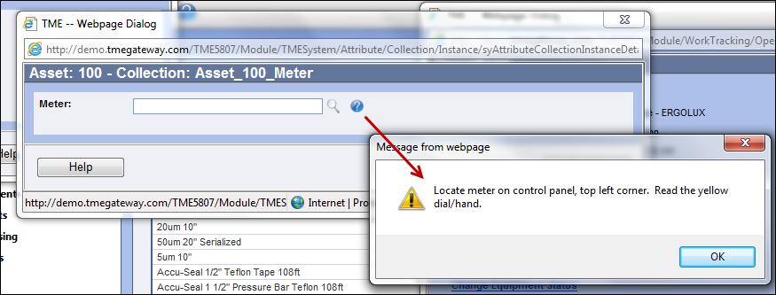
Figure 17 Example of Totalizer Variable
SPC and SPC Formula Variables
The SPC variable is used in lieu of the SPC module of TME versions prior to 5.8. Enter the values of the points in the fields provided. For SPC Formulas, the entries are made via Number variables configured to supply a value in the same manner as a regular Formula variable. To view the chart of previous entries, click on the icon to the right of the first point field. The X-Bar and R charts will appear.

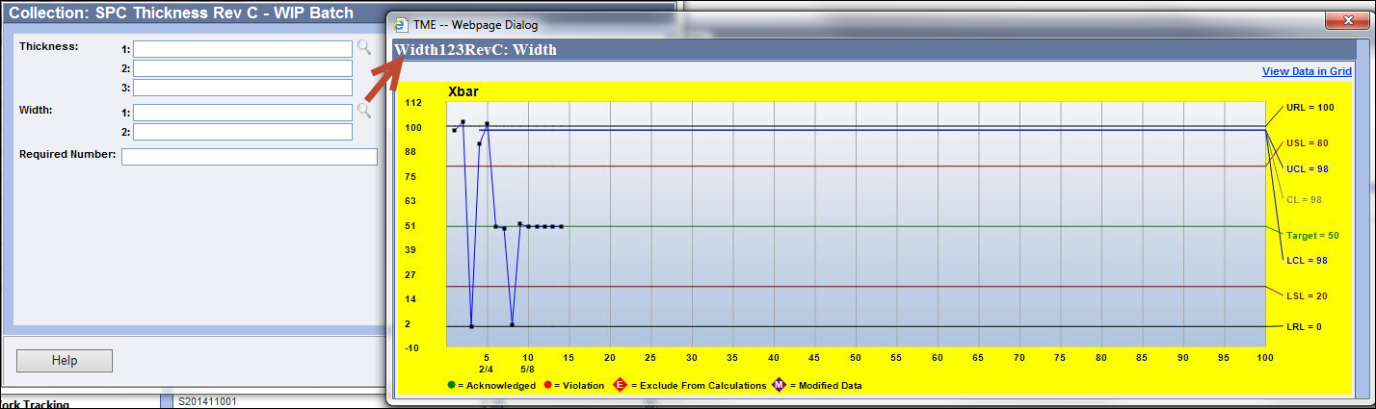
Figure 18 SPC Data Collection Screen and Xbar Chart

- View Data in Grid
The View Data in Grid link at the top right of the chart screen will show the data in a grid format.

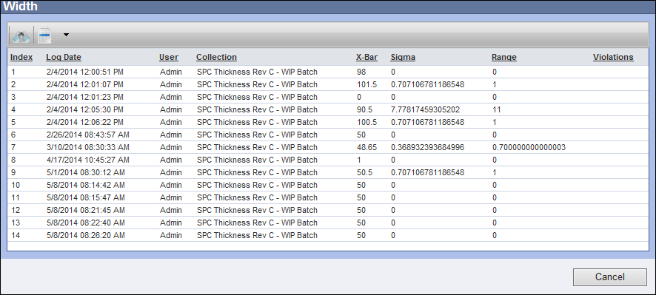
Figure 19 Data Viewed in Grid
- Point Detail Screen
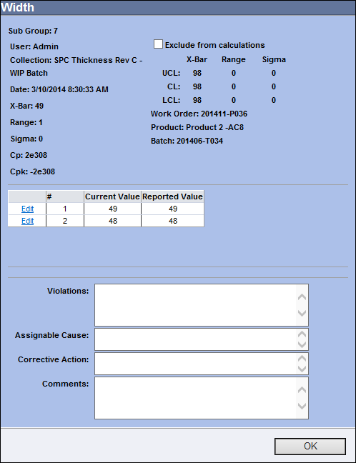
Click on a data point within either chart to display the Point detail screen for that point. The screen shows the Sub Group designation, control limits, X-bar, Range, Cp, Cpk, values reported and the violation(s) of any run rules.
The data point can be excluded from calculations by selecting the checkbox "Exclude from Calculations." The Exclude from Calculations tag will display in the charts above the data point to indicate its exclusion.
If a violation has been indicated, the Assignable Cause, Corrective Action and Comments may be typed in accordingly.
To edit the data point, click the Edit link to the left of the value number that needs to be changed. Type in the new values and click Update to save the change or Cancel to cancel. The Modified Data tag will display in the charts above the data point to indicate its modification.
Figure 20 Point Detail Screen

Click the OK button to close the screen.
Click Submit when all of the data has been entered.
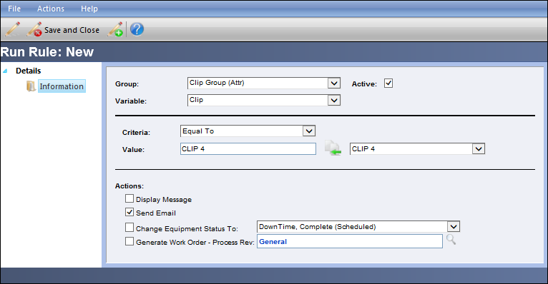
Run Rules
Run Rules may be set up by the TME Administrator to provided consequences should an entry be made that does not follow the “rules” for the given object. Consequences may include the displaying a message, sending an email, changing the equipment status (when associated with an Asset), or generating a work order (when associated with an Asset). These consequences can be set off when the entry does not equal, contain, does equal, is less than, etc., a given set of values. For an SPC variable, the run rules are based on violations to Western Electric rules (definitions for these rules are provided onscreen when set up).
Figure 21 Example of Run Rules Setup (See Chapter 10 Settings for More Detail)

For how to set up data collections and link to objects, see Chapter 10 Settings.

Non-Equipment Related Maintenance Request (NERMR)

In the event that you need to create a request that is not associated with any Asset then you should submit a Non-Equipment Related Maintenance Request (NERMR). This may be used for requests for light bulb replacement, repairing a broken table or maybe replacing a broken chair in the work area.

Exercise 4:
Send an NERMR.

- 1. Go to Operations.
2. Click on

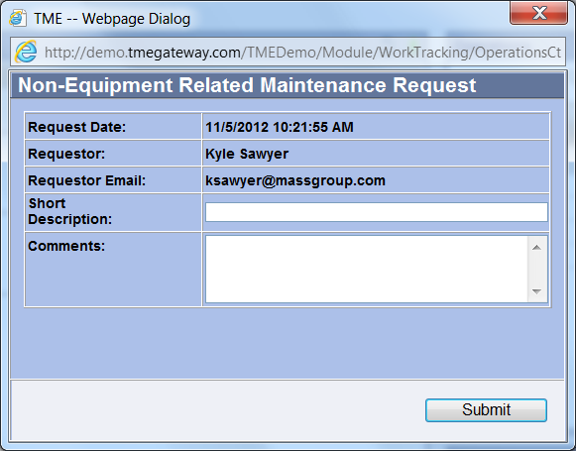
Figure 22 Non-Equipment Related Maintenance Request Screen

- 3. Type in the details of the request in the Comments field. You can also type in an alternate Short Description.
- 4. Click .
- 5. Verify that the request was sent by going to Work Tracking > Work Orders and
- searching for the request on the Work Order Viewer.

Equipment Related Maintenance Requests
Exercise 5:
Request downtime maintenance for an Asset (option is only available for Assets that are in an uptime state).

- 1. Go to the Operations screen of an Asset
- 2. Click on .

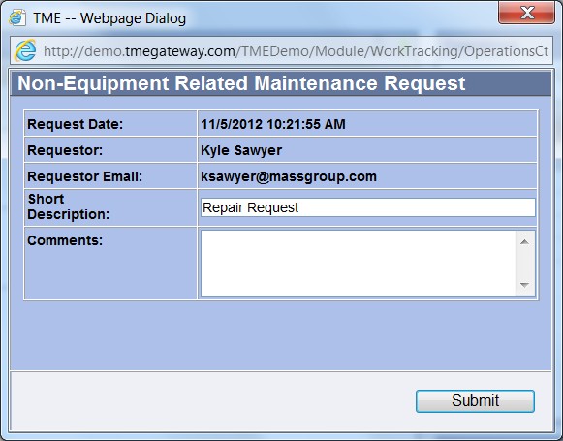
Figure 23 Repair Request Screen

- 3. Type in the details of the request in the Comments field. You can also type in an alternate Short Description
- 4. Click .
- 5. Verify that the request was sent by going to Work Tracking > Work Orders and
searching for the request on the Work Order Viewer.

The same process applies when submitting a service request (equipment is still operational or is already down and the status does not change upon submittal) by clicking on .

Messages

The Messages submodule allows Users and Administrators to send information regarding TME items to other Users. This is separate from any email system such as Microsoft Outlook or Lotus Notes. It can be accessed via Go To from the Task Bar or from the Driver's Seat within the User's Workspace. The data can be searched and sorted in order to easily access a specific record.

Reading Messages
Access Messages via Go To from the Task Bar or from the Driver's Seat within the Workspace. Select the Message and double click anywhere within the row or right click within the row and select "View." The Message screen appears. When finished reading the message, click .

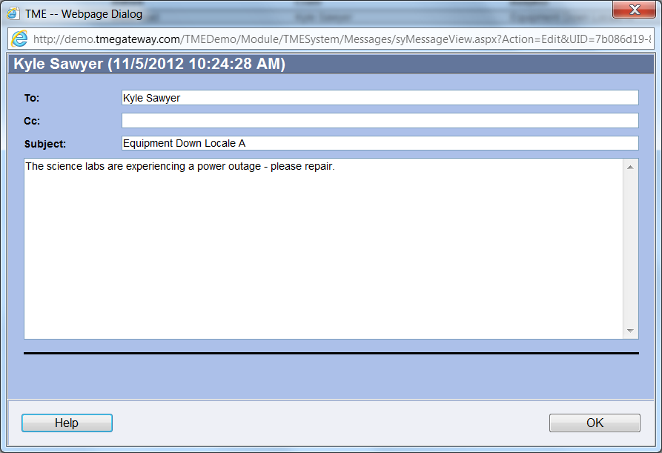
Figure 24 Message Screen

How to Send a New Message
To compose and send a new message, click which will open a blank Message screen.

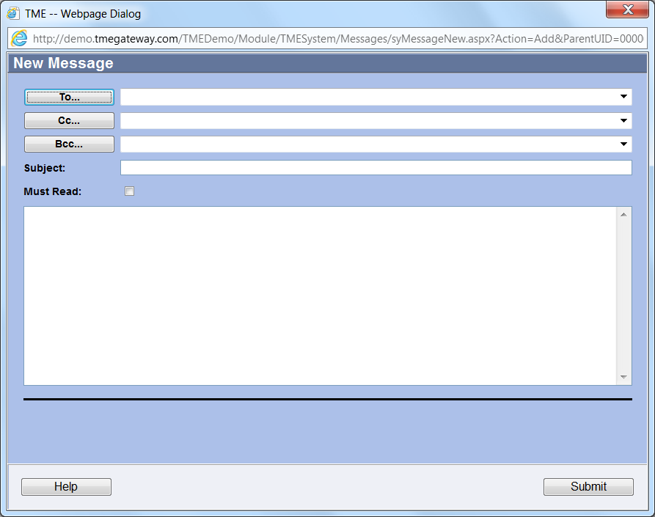
Figure 25 New Message Screen

Click on to bring up the list of Users entered in the system. This will bring up the Message Recipient(s) screen.

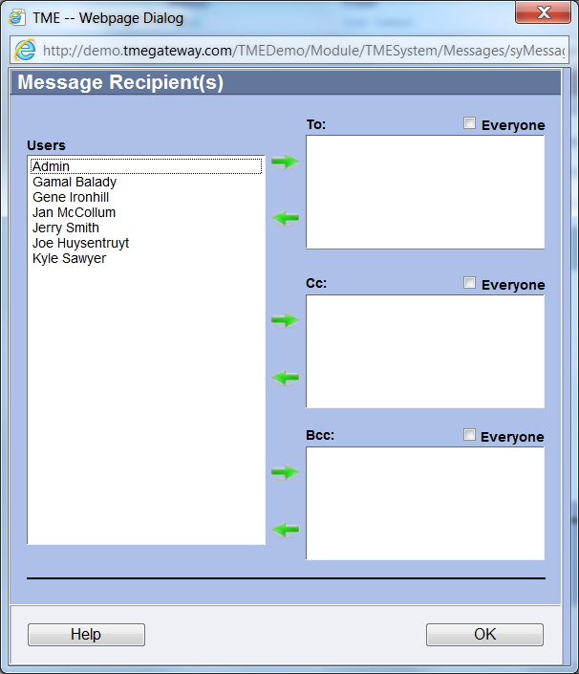
Figure 26 Message Recipient Screen

Select the name of a User from the Users field (click inside the field and start typing the first name to jump the cursor accordingly) and click the Add To icon . The User's name will move to the To: field. To select multiple Users, hold the Ctrl key on the keyboard while making the selections (or select a name, hold the shift key and select another name--all names in between and including those two will be selected), then click on the Add To icon . The same process works to select Users to Cc or Bcc on the message--click the proper icons to move the names to the proper fields. To remove Users as recipients, select the name(s) from the field and click the Remove From icon accordingly.
To send the Message to everyone in the system, select the checkbox "Everyone" (To, Cc, or Bcc). As Sent messages are not saved, Cc yourself in order to keep a copy of the message.
Once all the recipients have been selected, click . Type in the subject and body of the message. Select the Must Read checkbox only if the Users (the “To” recipients only, those who are Cc'd or Bc'd will not have enforcement) are to be required to read the message before being allowed to navigate through the menu items in TME.

Exercise 6:
Send a message to yourself and view it.

Reports

Reports are covered in another chapter. Please see Chapter 9 Reports.

